**1. pairs() in R**

pairs() function mainly used to plot a scatter diagram corresponding to each data frame.

Syntax: pairs(data)

This will return with Color, Labels, Panels, and by Group in-pairs plot.

We will make use of mtcars package here.

Let’s store some variable into data.

data<-dplyr::select(mtcars,mpg,disp,hp)

pairs(data)

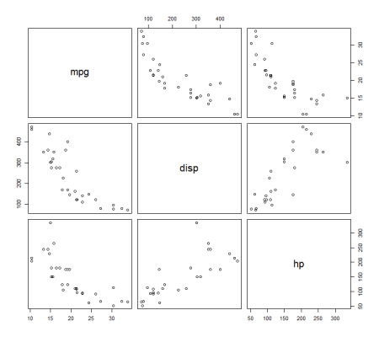

The diagonal boxes are column variables and the remaining combination of variables scatter plots.

You can modify the color, Shape of Points, Labels & Title

pairs(data,

      col = "blue",

      pch = 8,

      abels = c("var1", "var2", "var3"),

      main = "Piar Plot in R")

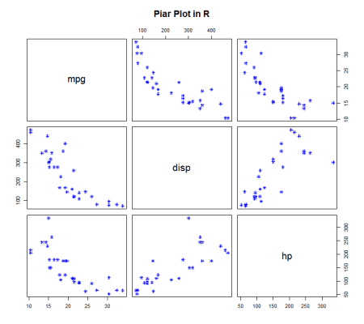

You can directly call from mtcars data set also.

pairs(~ mpg + disp + hp+wt, data = mtcars)

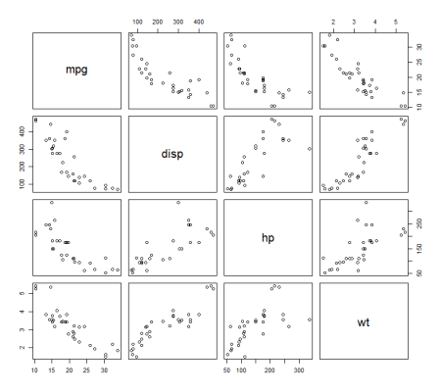

**2. ggpairs in R**

The ggpairs() function from the GGally package allows us to build a great scatterplot matrix. Scatterplots of each pair visualized in left side of the plot and Pearson correlation value and significance displayed on the right side.

If you are not installed the ggplot2 and GGally, Let’s install it.

install.packages("ggplot2")

install.packages("GGally")

library("ggplot2")

library("GGally")

ggpairs(data)+theme_bw()

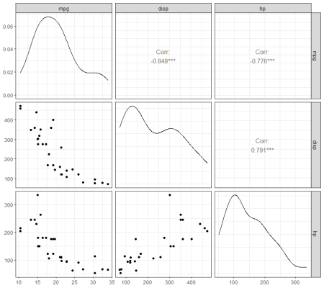

You can visualize differently also,,

ggpairs(data,

upper = list(continuous = "density", combo = "box_no_facet"),

lower = list(continuous = "points", combo = "dot_no_facet"))

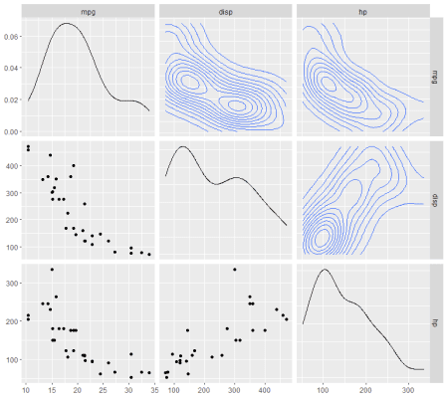

Let’s make use of some other dataset for better visulization.

data(tips, package = "reshape")

ggpairs(

tips[, c(1, 3, 4, 2)],

upper = list(continuous = "density", combo = "box_no_facet"),

lower = list(continuous = "points", combo = "dot_no_facet"))

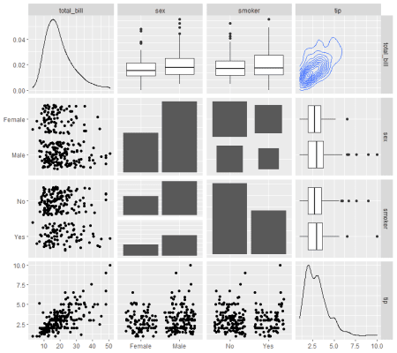

data(flea)

ggpairs(flea, columns = 2:4, ggplot2::aes(colour=species))

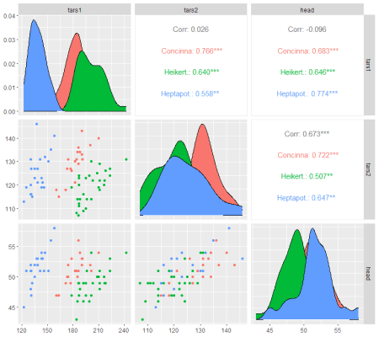

**Conclusion**

ggpairs plot provides the useful information and handy to use.